Chapter 4

Questions and Problems and Answers

- Explain the similarities and differences between pricing an option by its boundary conditions and using an exact option pricing formula.
When we price an option according to its boundary conditions, we do not find an exact price for the option. We provide only limits on the maximum and minimum price of an option or group of options. In the case of options differing by exercise prices or in the case of put-call parity we can price only the relationship or difference between the option prices. We cannot price each option individually without an option pricing model; however, an option pricing model must provide prices that confirm to the boundary conditions. Because boundary condition rules require fewer assumptions, we can say that they are more generally applicable and are more likely to hold in practice. However, they are incomplete in the sense that they do not tell us exactly what the option price should be, which is what an option pricing model does tell us.
- Explain how an n-period binomial option pricing model is similar to the Black-Scholes model.
In the one-period model, there are only two possible outcomes at expiration. In the two-periods model, there are three possible outcomes at expiration. As we extend the number of periods, the number of possible outcomes at expiration increases. There can be an infinite number of periods in which the length of each period can be made infinitesimally small. At this point the model comes close to approximately the assumptions of the Black-Scholes model. As a practical matter the binomial price tends to converge to the Black-Scholes price at 50-100 time periods.
- What is the principal benefit of a binomial option pricing model?
A binomial option pricing model enables us to see the relationship between the stock price and the call price. The model shows, in a simple framework, how to construct a riskless portfolio by appropriately weighting the stock against the option. By noting that the riskless portfolio should return the risk-free rate, we can see what the call price must be. We can also understand the forces that bring the call option price inline if it is not priced according to the model. In addition, the model illustrates the importance of revising the hedge ratio. Finally, the model is probably the best way to handle the problem of pricing an American option.
- Compare the variables in the binomial model with those in the Black-Scholes model. Note any differences and explain.
The variables in the binomial model are S (the stock price), E (the exercise price), r (the discrete risk-free rate), u (the return on the stock if it goes up), d (the return on the stock if it goes down) and n (the number of time periods). The variables in the Black-Scholes are S (the stock price), E (the exercise price), r_{c} (the continuously compounded risk-free rate), σ (the standard deviation of the continuously compounded return on the stock) and T (the time to expiration). The variables S and E are the same in both models. In the binomial model, r is the discrete interest rate per period. In the Black-Scholes model the interest rate must be expressed in continuously compounded form. The annual discrete interest rate ( r ) is related to the annual continuously compounded rate ( r_{c} ) by the formula, r_{c} = ln(1+r). Then the binomial rate per period is found as (1+r)^{T/n} - 1 . The up and down factors in the binomial model are directly related to σ in the Black-Scholes model by the formula u=e^{σ(T/n)^1/2} - 1 and d = (1 / ( 1+u)) -1. The time to expiration (T) in the Black-Scholes model is related to the length of each binomial period by the relationship T/n where n is the number of periods. Thus, all of the Black-Scholes variables are either equal to or directly convertible to binomial variables.
- What is the most critical variable in the Black-Scholes model? Explain.
The variance or standard deviation, sometimes called volatility, is the most critical variable for two reasons; (1) It is the only variable that is not directly observable and, thus, it must be estimated, and (2) The model is particularly sensitive to the estimate of volatility.
- Consider the various versions of the Black-Scholes model presented here that allow for the inclusion of dividends. Why are these models not strictly appropriate for pricing most exchange-listed options?
There are several models that adjust the stock price by reducing it by the present value of the dividends. One of the models assume that dividends are paid at discrete time points. And other one permits dividends to be paid continuously. While these models allow for the effect of dividends, they still apply only to European calls. Since most exchange-listed options are American, they tend to be under priced by the model, particularly when the dividends are relatively high. As noted in the text, there are more complex models that price American options, and the binomial model can also be used to price American options.
- Explain each of the following concepts as they relate to call options.
  - Delta
The Delta is the change in the call price for a given change in the stock price. Strictly speaking the delta applies only when the stock price changes by a very small amount. The delta also gives the hedge ratio, which tells how many shares of the stock must be held (or sold short) to hedge a given short (or long) position in calls. The delta is between zero and one and, as expiration approaches, converges to one if the option is in-the-money and zero if the option is out-of-the-money.
  - Gamma
Gamma is the change in Delta for a given (again very small) change in the stock price. The gamma measures the risk involved in not adjusting the hedge ratio to equal the delta. The gamma will be large when the option is at the money and nearly zero, when the option is deep in or out-of-the-money.
  - Rho
Rho measures the change in the option price when the risk-free rate changes. The relationship is nearly linear and is fairly weak. In other words the call price is not very sensitive to the risk-free rate.
  - Vega
Vega (also called Kappa and Lambda) measures the change in the option price for a change in the volatility. The relationship is nearly linear when the option is at-the-money. The option price is very sensitive to the volatility.
  - Theta
Theta is the relationship between the option price and time to expiration. For European calls, the theta is negative meaning that the option price will fall as expiration approaches.
- Suppose you are planning to use Black-Scholes model to price a call option. Unfortunately, you have no access to any information on treasury bills yields. You elect to substitute the yield on high-grade commercial paper. Assess the likely implication of this substitution.
Commercial paper yields are higher than treasury bill yields because the corporations that issue commercial paper could default while the US government, which issues treasury bills, will not default. Thus, the use of commercial paper as a substitute for treasury bills would overstate the effect of the risk-free rate on the model. However, the consequences of this error are not likely to be very great. Errors in the risk-free rate do not affect the option price that much. In addition, spread between commercial paper and treasury bill yields would not be very large because only firms with very low probabilities of default would be able to borrow by issuing commercial paper.
- Suppose you subscribe to a service that gives you estimates of the theoretically correct standard deviations of stocks. You note that the implied standard deviation of a particular option is substantially higher than the theoretical standard deviation. What action should you take?
If you accept the “theoretically correct” standard deviation as the true volatility, then the market price of the option is implying a higher volatility of the stock than is reasonable. That is, the implied volatility obtained by setting the Black-Scholes price equal to the market price is higher than it should be. This means that the market price is too high. You would consider selling the overpriced option, perhaps in conjunction with the purchase of the stock.
- Consider a two-period, two-state world. Let the current stock price be 45 and the risk-free rate is 5%. Each period the stock price go either up by 10% or down by 10%. A call option expiring at the end of second period has an exercise price of 40.
  - Find the stock price sequence.
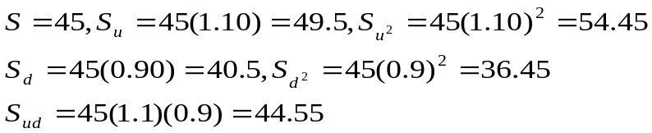
  - Determine the possible prices of the call at expiration.
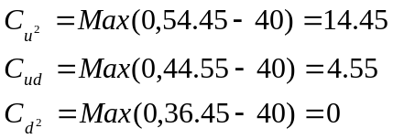
  - Find the possible prices of the call at the end of the first period.
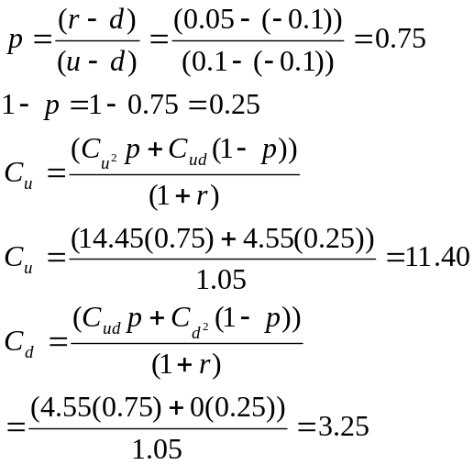
  - What is the current price of the call?
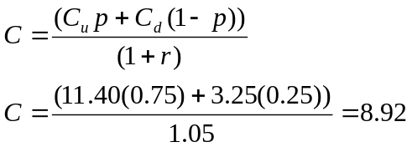
  - What is the initial hedge ratio?
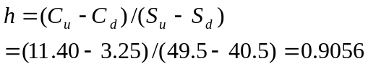
  - What are the two possible hedge ratios at the end of the first period?
If the stock goes up
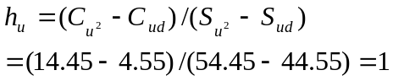

If the stock goes down
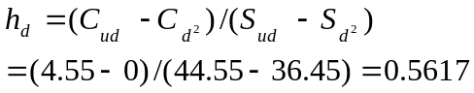

  - Construct an example showing that the hedge works. Make sure the example illustrates how the hedge portfolio earns the risk free rate over both periods.
Buy 906 shares and write 1,000 calls
Value of portfolio today:
906(45)-1,000(8.92) = 31,850
Value of portfolio one period later:
If stock goes up,
906(49.50)-1,000(11.40)=33,447
If the stock goes down,
906(40.50)-1,000(3.25)=33,443
These two amounts are essentially equivalent.
Return over one period = (33,447 / 31,850)-1 0.05
If the stock goes up to 49.5, h_{u} =1. Then buy 94 calls at 11.40 for $1,072. Borrow the money at the risk-free rate. Now you have 906 shares and 906 calls, which is a hedge ratio of 1. Your portfolio is:
906 shares at 49.50 = 44,847
-906 calls at 11.40 = -10,328
-loan = -1,072
33,447
Value of portfolio one period later

If stock goes up,
906(54.45)-906(14.45)-1,072(1.05) = 35,114
If stock goes down,
906(44.55)-906(4.55)-1,072(1.05) = 35,114
If the stock had gone down in the first period to 40.50, then h_{d} =0.562. Then sell 344 shares at 40.50. Take the proceeds of 13,932 and invest this amount for the next period in risk-free bonds earning 5 percent. Now you have 562 shares and 1,000 calls, which is a hedge ratio of 0.562. Your portfolio is:
562 shares at 40.50 = 22,761
-1000 calls at 3.25 = -3,250
Bonds = 13,932
33,443
Value of the portfolio at the end of the second period:
If the stock goes up,
562(44.55)-1,000(4.55)+13,932(1.05)=35,116
If the stock goes down,
562(36.45)+13,932(1.05)=35,114
The difference between 35,114 and 35,116 is due to rounding.
Return over two periods = 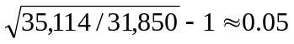
  - What would an investor do if the call were overpriced? If it were underpriced?
If it were overpriced, the investor should establish the same risk-less hedge by buying 906 shares and writing 1,000 calls. If it were underpriced, the investor should buy 1,000 calls and sell short 906 shares. This would create a type of loan in which money is received today and paid back later. The effective rate on the loan would be less than the risk-free rate.
- Consider the following binomial option pricing problem involving an American call. This call has two periods to go before expiring. Its stock price is 30, and its exercise price is 25. The risk free rate is 0.05. The value of u is 0.15 and the value of d is -0.1. The dividend yield is 0.06. Find the value of the call.
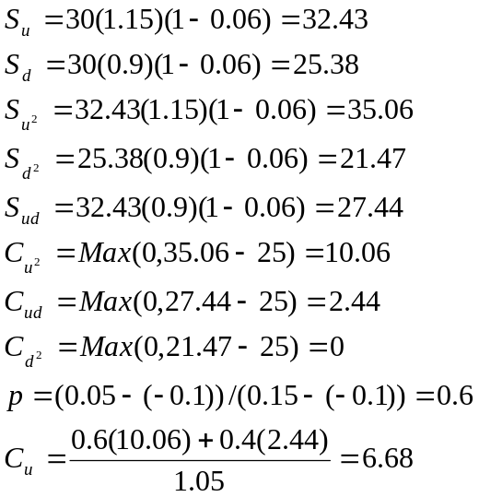
But worth 32.43-25 = 7.43 if exercised so C_{u} = 7.43
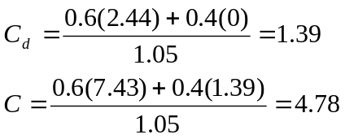
But worth 30-25 = 5 if exercised so C = 5

The following option prices were observed for calls and puts on a stock for the trading day of July 6 of a particular year. Use this information in problems 12 through 20. The stock was priced at 165 1/8. The expirations were July 17, August 21, and October 16. The continuously compounded risk-free rates associated with the three expirations were 0.0503, 0.0535, and 0.0571, respectively. Unless otherwise indicated assume the options are European.
Strike | Calls |  |  | Puts
Strike | July | Aug | Oct | Jul | Aug | Oct
155 | 10.5 | 11.75 | 14 | 0.1875 | 1.25 | 2.75
160 | 6 | 8.125 | 11.125 | 0.75 | 2.75 | 4.5
165 | 2.6875 | 5.25 | 8.125 | 2.375 | 4.75 | 6.75
170 | 0.8125 | 3.25 | 6 | 5.75 | 7.5 | 9

- Let the standard deviation of the continuously compounded return on the stock be .21. Ignore dividends. Answer the following:
  - What is the theoretical fair value of the Oct 165 call? Calculate this answer by hand and then recalculate it using either bsbin1.xls or bsbwin2.exe.
S = 165.125 E = 165 r_{c} = 0.0571 σ=0.21 T=0.2795 (102 days from 7/6 to 10/16)
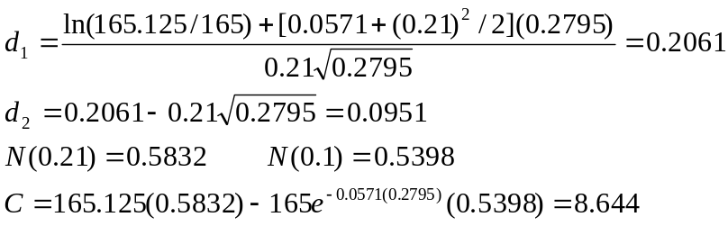
Using bsbin1.xls, you should obtain approximately 8.6999. using bsbwin2.exe, you should obtain approximately 8.6980.
  - Based on your answer in part a, recommend a riskless strategy.
The actual price is 8.125. The call appears to be underpriced. We should buy 1,000 calls and sell short 1,000(0.583)=583 shares and revise the hedge continuously so that the proper ratio of calls to shares is maintained.
  - If the stock price decreases by $1, how will the option position offset the loss on the stock?
For each dollar change in the stock price, the option price changes by approximately the value of N(d₁), its delta, of 0.583. So if 583 shares that were sold short decrease in value by one dollar, the gain is $583, but the 1,000 calls will decrease in value by $0.583 each. Since we are long the calls, we lose $583 on the calls. Thus, the loss on the long calls should be offset by the gain on the short stock.
- Use the Black-Scholes European put option pricing formula for the October 165 put option. Repeat parts a, b, and c of question 12 with respect to the put.
a) We have
Using bsbin1.xls, you should obtain approximately 5.9625. Using bsbwin2.exe, you should obtain approximately 5.9606.
b) The put appears to be overpriced at 6.75. You should sell 1,000 puts and sell short –(0.5832-1) 1,000 = 417 shares. However, we should note that in reality the put might not be overpriced since the Black-Scholes model does not account for the privilege of early exercise.
c) We would gain $417 by being short 417 shares. We would lose $417 on the puts because we are short 1,000 puts that increase in value by $0.417 each. Thus, the loss on the short puts is exactly offset by the gain on the short stock.
- Suppose the stock pays a $1.1 dividend with an ex-dividend date of Sep 10. Rework part a of problem 12 using an appropriate dividend adjusted procedure. Calculate this answer by hand and then recalculate it using either bsbin1.xls or bsbwin2.exe.
The time to the ex-dividend date is 66 days, so t = 66/365 = 0.1808. We adjust the stock price to
Inserting into the Black-Scholes model, we have
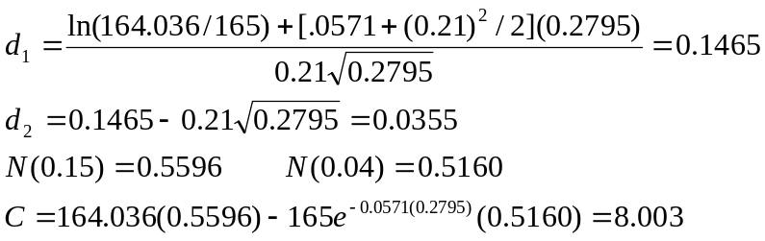
Using bsbin1.xls you should obtain 8.0794. Using bsbwin2.exe, you should obtain approximately 8.0786.
- On July 6, the dividend yield on the stock is 2.7%. Rework part a of problem 12 using the yield based dividend adjustment procedure. Calculate this answer by hand and then recalculate it using either bsbin1.xls or bsbwin2.exe.
We adjust the stock price to
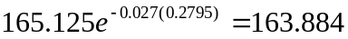
Inserting into the Black-Scholes model, we have
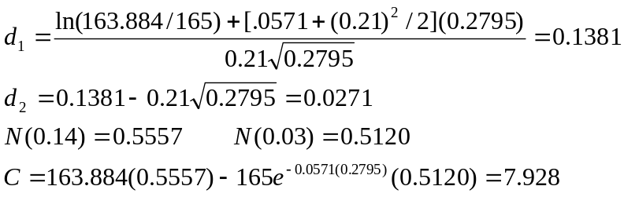
Using bsbin1.xls you should obtain 7.9944. Using bsbwin2.exe, you should obtain approximately 7.9939.

- Suppose on July 7 the stock will go ex-dividend with a dividend of $2. If the options were American, determine whether the July 160 call would be exercised.
On July 7 there will be 10 days remaining so the time to expiration will be 10/365 = 0.0274. As soon as the stock goes ex-dividend, its price will fall to 163.125. Then the options price will be
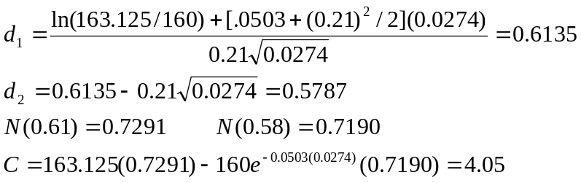
Exercise just before the stock goes ex-dividend would net 165.125-160 = 5.125 so you should exercise.

- Following is the sequence of daily prices on the stock for the preceding month of June:

Date | Price | Date | Price
6/1 | 159.875 | 6/16 | 162.000
6/2 | 157.250 | 6/17 | 161.375
6/3 | 160.250 | 6/18 | 160.875
6/4 | 161.375 | 6/19 | 161.375
6/5 | 160.000 | 6/22 | 163.250
6/8 | 161.250 | 6/23 | 164.875
6/9 | 159.875 | 6/24 | 166.125
6/10 | 157.750 | 6/25 | 167.875
6/11 | 157.625 | 6/26 | 166.500
6/12 | 156.625 | 6/29 | 165.375
6/15 | 159.625 | 6/30 | 162.500

Estimate the historical standard deviation of the stock for use in the Black-Scholes model. ((Ignore dividends on the stock)

Date | Price | R | R^{c}=ln(1+R) | (R^{c} - Mean)²
6/1 | 159.875
6/2 | 157.25 | -0.01642 | -0.01656 | 0.00030
6/3 | 160.25 | 0.01908 | 0.01890 | 0.00033
6/4 | 161.375 | 0.00702 | 0.00700 | 0.00004
6/5 | 160 | -0.00852 | -0.00856 | 0.00009
6/8 | 161.25 | 0.00781 | 0.00778 | 0.00005
6/9 | 159.875 | -0.00853 | -0.00856 | 0.00009
6/10 | 157.75 | -0.01329 | -0.01338 | 0.00020
6/11 | 157.625 | -0.00079 | -0.00079 | 0.00000
6/12 | 156.625 | -0.00634 | -0.00636 | 0.00005
6/15 | 159.625 | 0.01915 | 0.01897 | 0.00033
6/16 | 162 | 0.01488 | 0.01477 | 0.00020
6/17 | 161.375 | -0.00386 | -0.00387 | 0.00002
6/18 | 160.875 | -0.00310 | -0.00310 | 0.00002
6/19 | 161.375 | 0.00311 | 0.00310 | 0.00001
6/22 | 163.25 | 0.01162 | 0.01155 | 0.00012
6/23 | 164.875 | 0.00995 | 0.00990 | 0.00008
6/24 | 166.125 | 0.00758 | 0.00755 | 0.00005
6/25 | 167.875 | 0.01053 | 0.01048 | 0.00009
6/26 | 166.5 | -0.00819 | -0.00822 | 0.00008
6/29 | 165.375 | -0.00676 | -0.00678 | 0.00006
6/30 | 162.5 | -0.01738 | -0.01754 | 0.00034
 |  | Total | 0.01629 | 0.00253
 | Mean = | 0.01629 / 21 | 0.00078
 | σ² = | 0.00253 / 20 | 0.000126
 | σ = | 0.011240 | (This is daily standard deviation)
 | σ annualized= | 0.01124(250)^{1/2} | =0.1777

- Estimate the implied volatility of the Aug 165 Call. Compare your answer with that obtained in problem 17. Use trial and error. Stop when your answer is with 0.01 of the true implied volatility. Use the excel spread sheet bsbin1.xls or the windows program bsbwin2.exe.
At σ=0.20, the Black-Scholes price is approximately 5.30. At σ=0.19, the Black Scholes price is approximately 5.07. The implied volatility is, therefore, between 19 and 20 percent. This is slightly higher than the historical volatility obtained in problem 17, meaning that the volatility has recently increased.
- Repeat problem 18 using the approximation for an at-the-money call. Compare your answer with the one you obtained in problem 18. Is the approximation a good one?
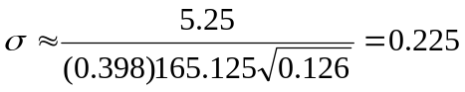
It is a little high but provides a good starting point. Of course, the call is slightly in the money any way. So the estimate will tend to be a little off.
- In problem 12, you estimated the value of Oct 165 call using the Black-Scholes model. Now estimate the value of that option using the binomial model for 1, 5, 10, 25, and 50 time periods. Use the excel spread sheet bsbin1.xls or the windows program bsbwin2.exe.
These calculations were obtained using bsbin1.xls.
For 1-time period C = 10.4586
For 5-time periods C = 9.0568
For 10-time periods C = 8.5342
For 25-time periods C = 8.7703
For 50-time periods C = 8.6701

- (Concept Problem) Find the value of an American put option using the binomial option pricing model. The parameters are S=62, E=70, r=0.08, u=0.1 and d=-0.05. There are no dividends. Use n=2 periods.
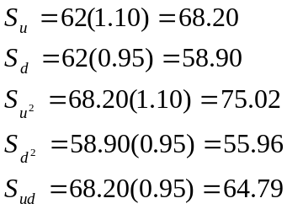

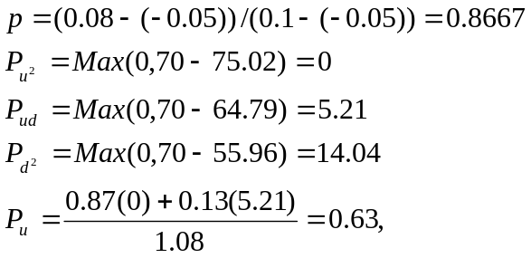
But worth Max(0,70-68.2)=1.80 if exercised. So P_{u} = 1.80

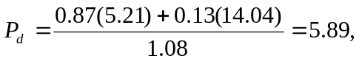
But worth Max(0,70-58.90)=11.10 if exercised. So P_{d} = 11.10.

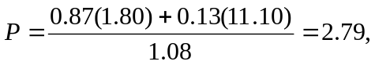
But worth Max(0,70-62)=8 if exercised. So P=8.

- (Concept Problem) Find the value of a European call option using the Black Scholes option pricing model. The parameters are S=80, E=80, r_{c} =0.05, σ=0.35 and T=0.25. Determine the Delta and estimate the change in the call price if the stock goes to the following prices; 70, 75, 78, 79, 81, 82, 85, 90. Then compute the Black-Scholes values for each of these new stock prices. Compare your estimates with the actual prices, and comment on the differences. Use the excel spread sheet bsbin1.xls or the windows program bsbwin2.exe.
Using the Black-Scholes model
C=6.0544 N(d₁) = 0.5631

The new call price is estimated as OLD CALL PRICE PLUS (STOCK PRICE CHANGE) (DELTA).
The actual call price is found by recomputing the Black-Scholes model.
New stock Price | Estimated New Call Price | Actual New Call Price | Difference
70 | 0.4234 | 1.8820 | 1.4586
75 | 3.2389 | 3.6010 | 0.3621
78 | 4.9282 | 4.9852 | 0.0570
79 | 5.4913 | 5.5055 | 0.0142
81 | 6.6175 | 6.6315 | 0.0140
82 | 7.1806 | 7.2360 | 0.0554
85 | 8.8699 | 9.2051 | 0.3352
90 | 11.6854 | 12.9436 | 1.2582

The estimates are far more accurate for small stock price changes.

